

An Urban Mosque Scenario

A Computer Graphics-Based Animated Visualization Project

Submitted By
Name & ID:
Jobair Hossain – 043232005101171
Soyeb Hossain Anik – 043232005101150
Sumiya Tabassum – 043232005101132
Waliul Haque Nipun – 043232005101147
- Department: CSE

Submitted To

Course Teacher: Sonia Afroz (Lecturer)
- Course Title: Computer Graphics Lab
- Course Code: CSE 358

Submission Date :

Table of Contents
- Introduction
- Idea and Motivation
- Technology Stack
- Methodology
- Result and Discussion
- Limitations
- Future Work
- Conclusion
- References

1. Introduction
Computer graphics plays an important role in modern software development, simulation, gaming, architectural visualization, and multimedia systems. Through graphical programming, developers can create realistic environments and animations that improve visual understanding and user interaction.
The project “An Urban Mosque Scenario” was developed to create a graphical urban environment containing a mosque and surrounding elements using OpenGL. The project demonstrates the application of computer graphics concepts including drawing primitives, transformation, animation, and rendering.
This project also helps students gain practical experience in OpenGL programming and graphical system development.

2. Idea and Motivation
The primary idea behind this project is to create an animated urban mosque environment that visually represents the cultural and architectural beauty of a mosque within a city setting.
The motivation for developing this project comes from the growing importance of graphical visualization in modern applications. The project was designed to combine technical learning with architectural representation using computer graphics techniques.
The project also aims to:
- Improve understanding of OpenGL graphics programming
- Demonstrate animation and rendering techniques
- Develop practical knowledge of scene composition
- Create a visually interactive environment
- Enhance problem-solving and graphical development skills

3. Technology Stack
The project was developed using the following technologies and software tools.
Component | Technology
Programming Language | C++
Graphics Library | OpenGL
Utility Toolkit | GLUT
IDE | Code::Blocks
Operating System | Windows

3.1 Libraries Used

OpenGL
OpenGL was used for rendering graphical objects and managing scene visualization.

GLUT
GLUT was used for window management, keyboard interaction, and event handling.

Windows Library
The Windows library was used for platform-specific operations.

Sample Header Files
#include <GL/glut.h>
#include <windows.h>
#include <math.h>

4. Methodology
The project was developed following a structured workflow similar to the waterfall software development model.

4.1 Requirement Analysis
At the beginning of the project, all required scene elements were identified. These included:
- Mosque structure
- Urban road
- Trees and environment
- Sky and background
- Animation objects
- User interaction system

4.2 System Design
A visual scene layout was designed before implementation. The mosque was placed at the center of the urban environment while surrounding graphical elements were arranged systematically.
The design focused on:
- Balanced scene composition
- Proper object placement
- Smooth visual appearance
- Animation flow

4.3 Object Development
Different objects were created using OpenGL primitives such as polygons, lines, circles, and rectangles.

Example Drawing Code
glBegin(GL_POLYGON);
glVertex2f(x1, y1);
glVertex2f(x2, y2);
glVertex2f(x3, y3);
glEnd();
The mosque structure, roads, trees, and environmental objects were built using these graphical primitives.

4.4 Animation Implementation
Animation techniques were implemented to create movement within the scene.

Animation Features
- Moving objects
- Dynamic environment
- Continuous scene rendering
- Real-time screen update

Sample Animation Code
position += speed;
glutPostRedisplay();

4.5 User Interaction
Keyboard controls were implemented to allow user interaction.

Sample Keyboard Control Code
void keyboard(unsigned char key, int x, int y)
{
if(key == 'd')
{
dayMode = true;
}
}

4.6 Testing and Debugging
The project was tested repeatedly to ensure smooth rendering and correct animation behavior.
Testing focused on:
- Rendering accuracy
- Animation smoothness
- Performance optimization
- Bug fixing
- Keyboard functionality

5. Result and Discussion
The project achieved its primary objectives successfully. The final output demonstrates practical implementation of computer graphics concepts using OpenGL.

Achievements
- Successful urban mosque visualization
- Smooth animation rendering
- Interactive graphical environment
- Proper implementation of OpenGL primitives
- Efficient scene management
The project also improved understanding of graphical programming, animation systems, and rendering techniques.
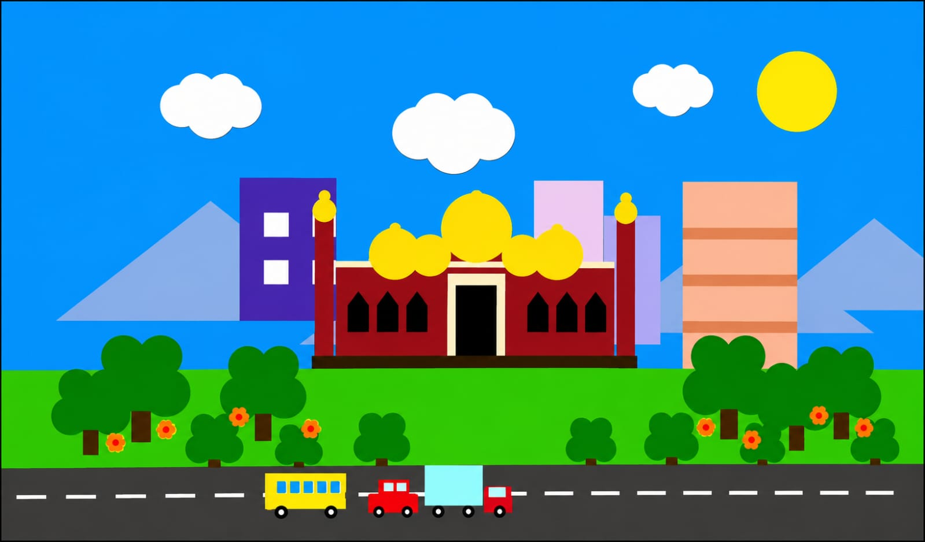

6. Limitations
Although the project was completed successfully, some limitations remain.

Current Limitations
- Limited graphical realism
- No advanced texture mapping
- Basic lighting implementation
- Limited user interaction
- Fixed environmental conditions
- Lack of advanced 3D rendering
These limitations can be improved in future versions.

7. Future Work
Several improvements can be added to enhance the project in the future.

Proposed Future Improvements
- Add realistic texture mapping
- Implement advanced lighting and shading
- Develop a complete 3D environment
- Add weather effects such as rain or fog
- Include sound and environmental audio
- Improve user interaction features
- Optimize rendering performance
- Add camera movement and zoom functionality

8. Conclusion
“An Urban Mosque Scenario” successfully demonstrates the practical application of computer graphics concepts using OpenGL and C++.
The project combines graphical rendering, animation, and scene composition techniques to create a visually appealing urban mosque environment. Through this project, valuable experience was gained in OpenGL programming, animation development, object rendering, and graphical system implementation.
The project serves as an effective academic demonstration of computer graphics principles and provides a strong foundation for future advanced graphical applications.

9. References
- OpenGL Programming Guide
- GLUT API Documentation
- LearnOpenGL Tutorials
- Computer Graphics Principles and Practice
- OpenGL Official Documentation
- C++ Graphics Programming Resources
- Online Tutorials and Academic Articles Related to Computer Graphics

Thank You

